Create a Data-Driven Story with Power BI Reports
Introduction
Organizations use reports to monitor and record performance and identify trends and variances

Reports should be:
- concise
- accurate
- well-designed
- display information in a compelling way that is simple to navigate and complies with current accessibility standards

Design a Report Layout
Page layouts are dependent on business requirements, context of the underlying data, and the output requirements

A dashboard should:
- present high-level information on a single page.

A report should have a multi-perspective view into your dataset, with visuals that represent different findings and insights from the dataset.

Report Design Best Practice
Consider the audience:
- If your report users have a technical background:
  - use multiple, complex visuals that offer the most detail, along with interactive slicers
- If your report users want quick insights at a high-level:
  - use a small range of basic visuals

The GOAL of the REPORT is to: provide the audience with the information that they need, in an optimal way.

In most cases a simple visual is all that is needed
note that the more visuals lead to a bigger impact on the performance of the report

alongside, adhering to organizational style guidances such as colour schemes and fonts

Key Guidelines when creating a well-designed report layout:
- Draw a sketch of your report layout – get an idea of what it will look like BEFORE you spend considerable time physically designing it
- Focus on the most important information – highlight key parts with a bright colour or summary icon
- Select the right background for the context of your report
  - A white background = clean and professional
  - A black background = draw attention to colourful highlights on the report
  - Using images as a background can add visual interest

The following is an example of a POORLY DESIGNED report layout.

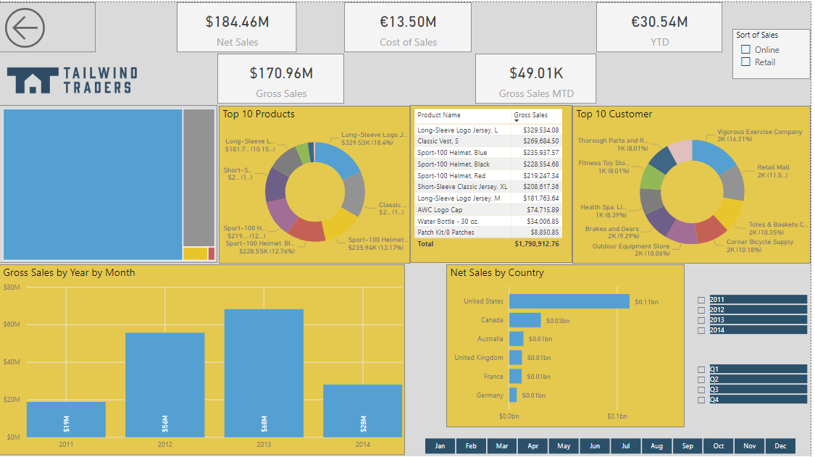
Report Page
The default display is Fit to page – contents are scaled to best fit the page

To access the page settings, select the whites-space on the report canvas, to open the Format pane
=> you can then configure the following settings:
- Page information
- Page alignment
- Page size
- Wallpaper
- Page background
- Filter pane

Visuals
Number of Visuals
Limit the number of visuals of a page
Ask yourself if this visual is necessary for the report

Visuals are the key factor in the performance of the report
The fewer visuals => the better the performance

You can provide information in other ways, such as:
- drillthrough pages
- report page tooltips

Position of Visuals
Larger or smaller depending on importance – for a more effective display

Best practice to place the most important visual in the upper-left corner of the report as users most likely read left-to-right and top-to-bottom

To evenly distribute between visuals, you can use the align function

Use the CTRL + click to select all visuals that you want to align, select the Format tab and then select Distribute horizontally

An example is shown below:
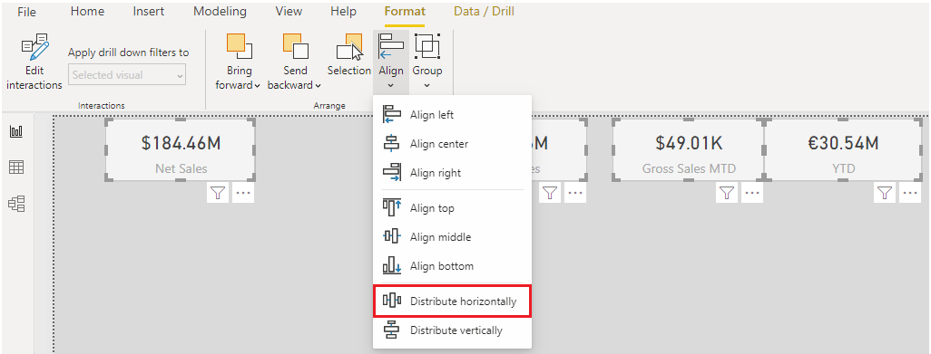
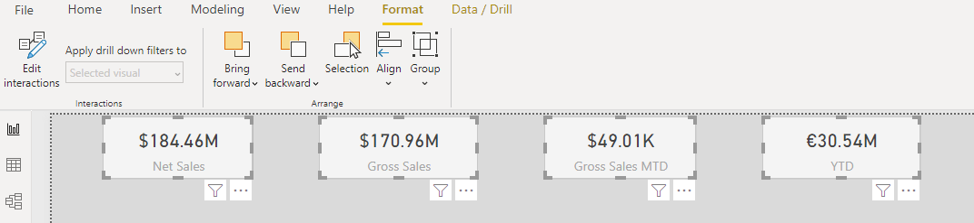
Size of Visuals
Determine the size such that the information is displayed most optimally and clearly

e.g., a visual of a small car – the visual should be smaller in size
whereas a scatter chart visual with extensive data – the visual should be larger in size

Interaction of Visuals
visuals react to other visuals in relation to that element, they might highlight or filter the specific data that they display

Understand how these interactions work and consider how they might affect the overall user experience

hence you might:
- change a filter action to a highlight
- prevent an interaction from happening

Hierarchies in Visuals
Consider how hierarchies will affect how the data displays in the visuals and the navigation experience of the report user

You can also determine the hierarchical path so that you have full control over what level of detail can be accessed

Report Accessibility
Consider that users might have hearing, motor, cognitive, or visual impairments and design a report accordingly

Accessibility Features
The following features are already built in to Power BI desktop:
- Keyboard navigation
- Screen-reader compatibility
- High-contrast colour views
- Focus mode
- Show data table

Accessibility features that you do need to configure include:
- Alt text
- Tab order
- Titles and labels
- Markers
- Themes

Alt Text
To accommodate report consumers who use screen readers, you can use alternative (alt) text to describe the appearance and function of objects (such as visual, shape, and so on) on the report page

ensures that users understand what you are trying to communicate with those objects, even if they are unable to see them

To add alt text to an object, select that object, and in the Visualization pane
=> open the Format pane.
=> expand the General section
=> scroll to the bottom of the options
=> enter a description in the Alt Text box

You can also use Data Analysis Expressions (DAX) measures and conditional formatting to create dynamic alt text

To apply conditional formatting, right-click the Alt Text box, and select Conditional formatting
=> configure settings as required

Tab Order
To help keyboard users navigate your report in an order that matches the way that visual users would
you can SET THE TAB ORDER

To set the tab order, select the View tab in the ribbon and then select Selection pane that displays, => use the arrow buttons to move the objects to the correct order
=> or select an object with your mouse and drag it into the position that you want in the list

You can also hide an object from the tab order, this is useful for decorative shapes and images in the report

an example of tab order is seen below:
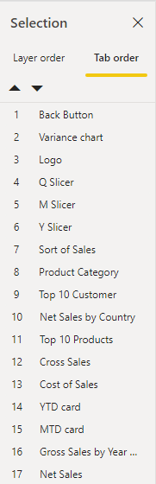

Titles and Labels
In order to help users, you should provide clear, concise, and descriptive titles for your visuals and report pages

Avoid using acronyms or jargon that new users or users who are external to your organization will not understand

An example of good titles (the right titles) is seen below:
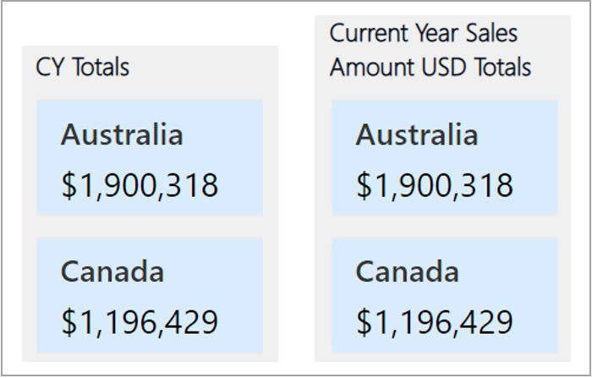

Make sure that all labels are easy to read and understand

You can turn on or off the labels for each series in your visual or position them above or below a series to make them clearer

This is depicted below:
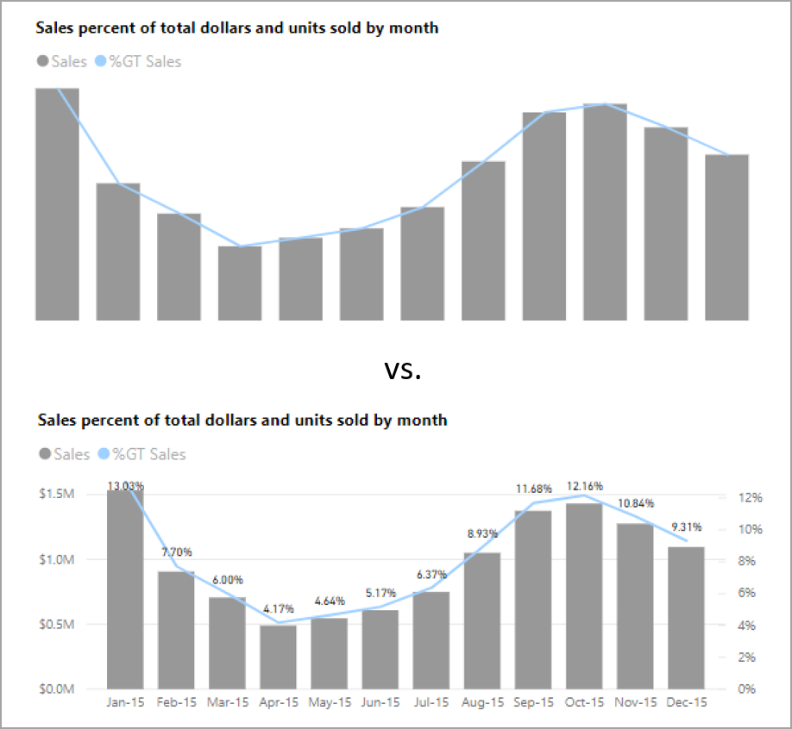

Markers
Use markers to convey different series

For line, area, and combo visuals, including scatter and bubble visuals, you can turn on markers and use a different shape for each line

You can turn on markers using the following selection, the results are also depicted below:
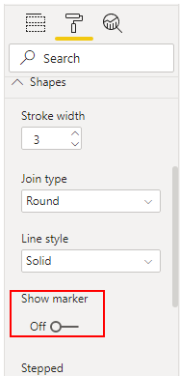

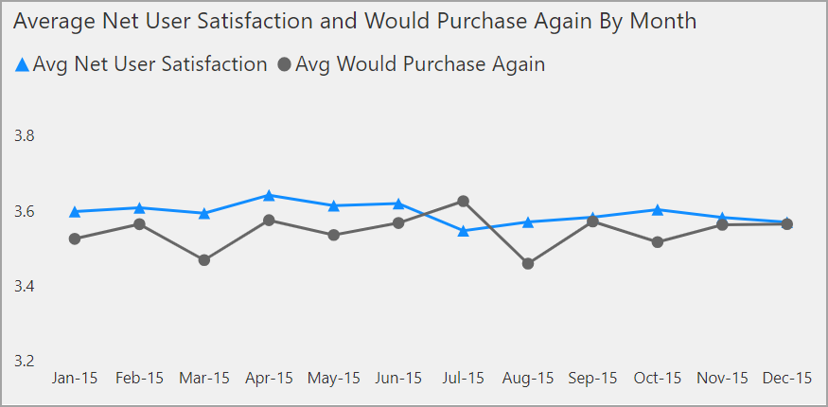

An example of the previous report with an improved design:
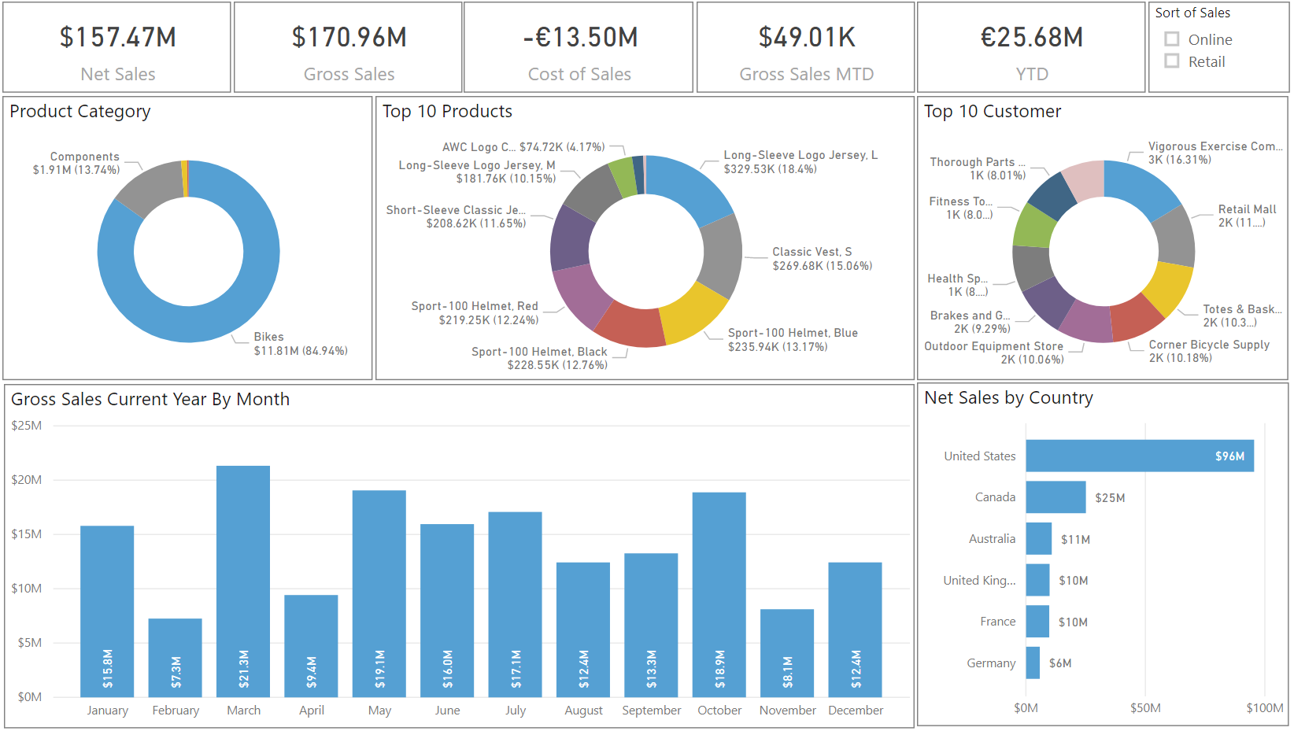

Add Buttons, Bookmarks, and Selections
You can use Bookmarks, Buttons, and Selection features to make your report more compelling, interactive, and simpler for users to navigate

Bookmarks
Capture the currently configured view of a report page so you can quickly return to that view later.

You can use bookmarks to build a PowerPoint-like presentation that goes through the bookmarks in order, thereby

Bookmarks are used to capture a snapshot of the page in its current state

When you add a bookmark you can view the list of all items on the page.

Hence, you can make changes to the visuals and SAVE A SNAPSHOT OF IT into a variable (bookmark)

In summary,
you would select items that you want to show/hide on the page
=> add a bookmark (that saves a snapshot of the current elements on the screen)
=> then give it a descriptive name

You can now assign those bookmarks to buttons so that users can switch between the bookmarks

Buttons
Create a more interactive experience for the report users. With the addition of buttons have assigned actions,

your report then behaves similar to an app
where users can then hover, select, and interact more with the content.

Can be used to:
- switch between two visuals in a report
- drill down into data in a visual
- move from one page in the report to another

an example function can be for switching between two bookmarks

you can add Actions to the button

The options for button Action types are as follows:
- Back – returns the user to the previous page of the report. Useful for drill-through pages or pages that are accessed from one main page
- Bookmark – presents the report page that’s associated with a bookmark
- Drill through – brings the user to a drill through page that is filtered to their selection
- Page navigation – brings the user to a different page within the report
- Q & A – where users can enter questions to quickly find the information that they are looking for and specify the type of visual that they want to see the information displayed in
- Web URL – opens a website in a new browser

Selections
Allows you to determine what items in the report are visible and what items are hidden.

Selections are used alongside bookmarks and buttons

Design Report Navigation
Report navigation is the way in which your report users move from one page in the report to the next, one visual to another, and return to where they started

You can use a range of buttons and bookmarks when designing your report navigation, and further enhance this navigation experience with the use of conditional formatting

Add Navigation Buttons
To design navigation in the report, you can create a new Navigation page in your report and add navigation buttons on that page

You can also hide pages such that they are only accessible through the Navigation page button

Set the Navigation Destination
You can use conditional formatting to set the navigation destination based on the output of a measure

You can do this to save space on the report. Rather than using multiple navigation buttons, you can use a single button to navigate to different pages based on the user’s selection

This is shown below:
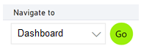

Other reasons for doing this are:
- To specify the logical path that your report users should take.
- To tell a data-driven story
  - e.g., tell a message to a superior and back it up with the data – useful to drive change, such as increasing sales
- To create a reporting portal where users can navigate to a set of reports

Apply and Customize Themes
You can apply themes to reports in order to give a unified look to text visuals and other aspects of the report

Customizing REPORT themes can be done in Power BI Desktop

An example of changing a report theme on Power BI Desktop can be seen below:
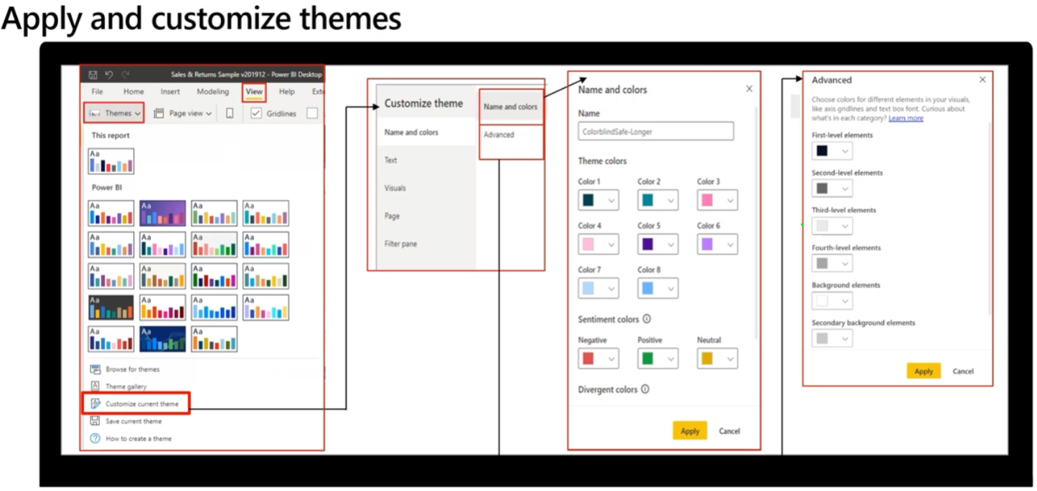
Customizing DASHBOARD themes can be done in Power BI Service
You can select from a variety of themes such as Light, Dark, Color-blind friendly and Custom

Conditional Formatting
Conditional formatting allows you to specify customised cell colours, including colour gradients that are based on field values

Additionally, you can use conditional formatting to represent cell values with data bars, KPI, icons, or active web links

This is useful for highlighting or differentiating the data that is displayed in the visual
Will help you and others see key data insights easily
An example of conditional formatting:
If the sales figure falls below zero, then you could display this value in red, a colour that is associated with danger

this means that users can see it clearly and know they need to take immediate action

Conversely, if sales figure goes over a target, then you could display this value in green, to signify that the target is met and all is going well

The conditional formatting option can be accessed in the Format pane of the specific visualization after selecting the visualization.

An example of what configuring the conditional formatting can look like is seen below:

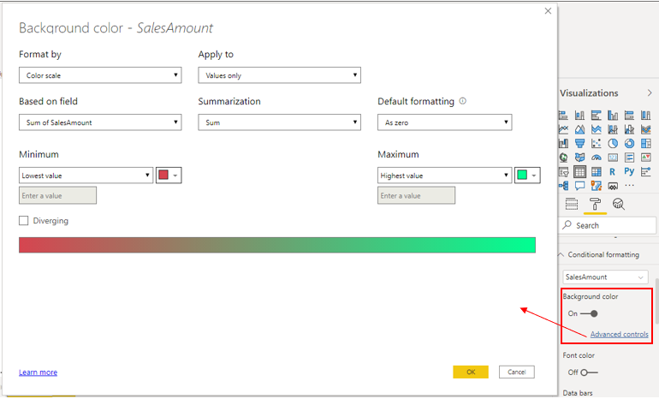
In most cases, Power BI conditional formatting will automatically detect the highest and lowest number in each column and will apply background formatting according to the values
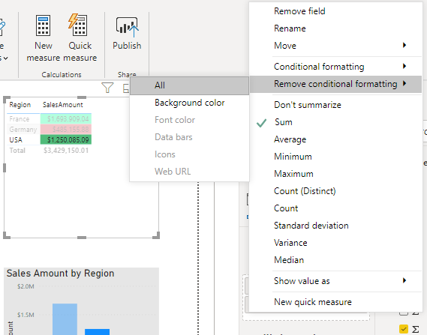

You can also remove and view the effects of conditional formatting in the image below:

Use Advanced Interactions and Drill Through
To ensure that you have full control over the behaviour of the report and so that you can determine the user experience, you can edit the default interactions and use the drill-through features

Edit Default Interactions
You can use visual interaction controls to customize how the visualization on the report page impact each other through two ways:
- Filter
- Highlight

For example, when you select an item in a visual, the other visuals update to display data for that item; they might be highlighting or filtering the selected data

You can stop this occurrence from happening, or change a highlight action to a filter action and vice-versa

In order to enable visualization controls, SELECT a visualization, go to the Format tab in the ribbon, and then select Edit interactions
=> Edit interactions button will then turn grey in order to indicate that it is enabled
=> the Filter, Highlight and/or None icons are then added to the OTHER visualizations on the report page

NOTE: You can remove interactions altogether by selecting the None option

Filter
This means that the selection is cross-filtered because the Filter icon is displayed in bold

Filter means that all other values/categories are removed from the visualization and only the specific highlighted value/category values will be SHOWN in the other visualizations

Hence, if we want to know the effects of ONE specific value/category on the OTHER visualizations then Filter is the right option

The standard visualization filtering tool – you select something (category/value) on a visual and other visuals also display that something (category/value)

Highlight
You can also change the interaction to cross-highlight by selecting the Highlight Icon

In contrast to filter, where it removes every other value except the SELECTED value/category in the visualization

Highlight will display the SELECTED value/category in OTHER visualizations WHILE ALSO displaying the context (the values of other categories/selections). Hence, we can see the context of the selection

This allows us to visually determine how much our selected value/category make up the total calculation/context of the entire column – a percentage view of the entire column in a way

An example of a highlight is seen below:
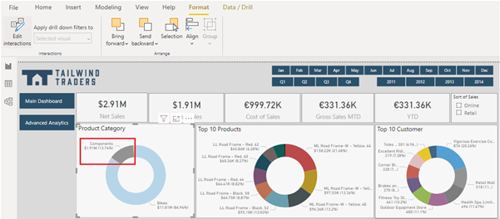

Use the Drill-Through Feature
You can use the drill through feature to create a page in the report that focuses on a specific entity, such as product category, or region

Hence the idea is that you create a new page that contains FURTHER data of a specific entity

You do this by first creating a new page in the report, and naming it based on the feature you wish to FURTHER explain.

You can then access this page when you drill through from the related visual that are on other pages

Add visuals (e.g., tables) for further detail (e.g., Category, SubCategory, Country) to the page
Note that Power BI Desktop automatically creates a Back button visual on the page for you

This button is for navigation purposes, so your report can return to the report page from which they came

An example of it and a created drill-through page can be seen below:
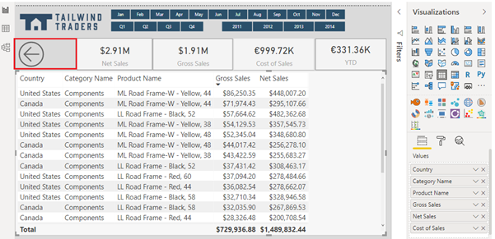

In order to then use this created drill-through page, you would right-click a data point on a visual in another report page, select Drill-through, and then select the focused page (the page you created for further detail) to get details that are filtered to that context

Cross-Report Drill-Through
The cross-report drill-through feature allows you to contextually jump from one report to another report in the same Power BI service workspace or app

This feature allows you to connect two or more reports that have related content.

You can also pass filter context along with that cross-report connection

Hence, allowing you to select a data point on a visual in one report, and then drilling-through to a related, detailed, information that is in another report

Apply Slicing, Filtering, and Sorting
Power BI Desktop provides three tools that you can use to edit, and configure interactions between visualizations

The process of filtering allows you to remove all the data that you don’t need, so you can focus on the data that you do need
You can apply filtering directly by using the Filters pane or by adding and using a slicer

Slicers and filters are similar
both let you filter unnecessary data

The process of sorting allows you to highlight the important information without removing any of the data

Slicer
A type of filter that you can add to the report, so users can segment the data in the report by a specific value such as by year or geographical location

Slicers narrow the portion of the dataset that is shown in the other report visualization:
You can then use them to:
- Provide quicker access to commonly used or important filters
- Simplify a user’s ability to see the current filtered state without having to open a drop-down list
- Filter by columns that are unneeded and hidden in the data tables
- Create more focused reports (by putting slicers next to important visuals)
- Defer queries to the data model by using a drop-down slicer, particularly when you are using DirectQuery

An example of a slicer is seen below:

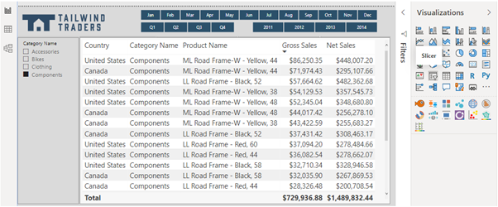
in the Format pane, expand the Selection controls section to view the following options:
- Single select
  - Option is OFF by default. Ensures that only one item can be selected at a time
- Multi-select with CTRL
  - Option is ON by default. Allows you to select multiple items by pressing the Ctrl key
- Show “Select All”
  - Option is OFF by default. If this option is turned ON. A Select all check box is added to the slicer. You might want to add this option in order to quickly select or clear all items in the list. If you select all items, selecting an item will clear it, allowing an is-not type of filter

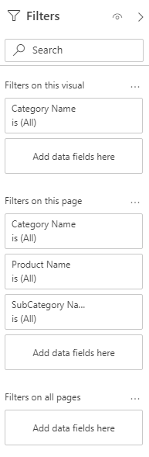
Filter
While slicers are useful, if you want to filter the data in a basic way, you don’t need to add slicers to the report

Power BI has a Filters pane that can handle basic slicer operations
Hence, depending on requirements you might save time and effort by avoiding the use of slicers and using the Filters pane instead

By using this pane, as shown on the right.
You can reduce the total number of visuals in the report,
which will improve performance

Customize Filter
The filters allow users to interact with the visual at the report, page, and visual level

You can customize the filter as follows:
- Add and remove fields to filter on
- Change the filter state
- Format and customize the Filters pane so that it seems part of your report
- Define whether the Filters pane is open or collapsed by default when a consumer opens the report
- Hide the entire Filters pane or specific filters that you don’t want report consumers to see
- Control and bookmark the visibility, open, and collapsed state of the Filters pane
- Lock filters that you don’t want customers to edit
In order to apply a filter, drag and drop a field from the Fields pane into the relevant section of the Fields pane

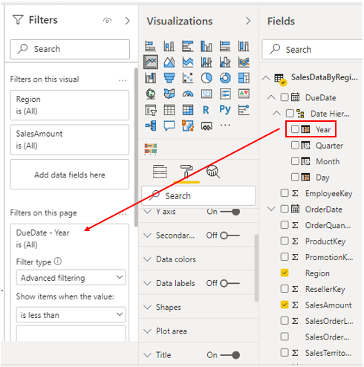

Sort Data
Sorting helps you display the most important data in the most logical way, such as in alphabetical or numerical order

This helps when you are making significant business decisions

For example,
- if you display products with higher sales first, then you are helping the users to see which product is the most popular among the customer base
- also, if you display products with lowest sales first, then you can help users see which products can be discontinued or replaced with new products to help increase revenue

To sort a visual, start by selecting More options.. button in the upper-right corner of the visual, where you will have three sorting options
- Sort descending
  - Sorts the visual by the selected column in the order of the greatest value to smallest value
- Sort ascending
  - Sorts the visual by the selected column in the order of the smallest value to greatest value
- Sort by
  - Sorts the data by a specific column. Hover over this option to display the list of columns that you can select from

An example of sorting a column by its Gross Sales column can be seen below:
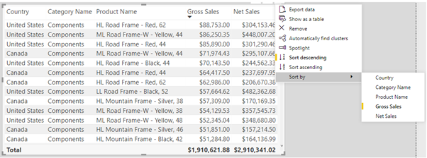
Analyze in Excel Feature
This feature allows us to export the data model from the Power BI report to a blank Excel workbook, which allows you to interact with it using the PivotTable

The sensitivity label applied to Power BI datasets is automatically applied to the Excel file

It supports row-level security (RLS)

It allows Power BI IMPORT mode datasets to preserve hierarchies
Hence, we CANNOT use it with DirectQuery or Connect Live

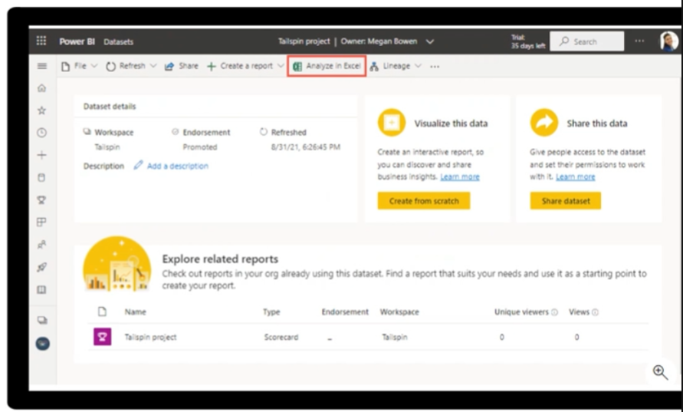
The example above implies that the Analyze in Excel Feature is available through the Power BI Service section

Paginated Reports
Paginated reports allow report developers to create Power BI artifacts that have tightly controlled rendering requirements

Paginated reports are ideal for creating sales invoices, receipts, purchase orders, and tabular data

Paginated reports give “pixel-perfect” view of the data meaning that you have total control of how the report renders.

Power BI paginated reports are descendants of SQL server Reporting Service (SSRS), which was first introduced in 2004

Paginated reports are built on the Power BI Report Builder application

Paginated reports are a feature that require a Power BI Premium subscription

When Paginated Reports are The Right Fit
You can use them for operational reports with tables of details and optional headers and footers

Additionally you can use them when you expect to print the report on paper, or when you want an e-receipt, a purchase order, or an invoice

Paginated reports also render tabular data exceedingly well. You can also have customized sort orders, clickable-headers, and URLs in results allowing for simple integration with custom applications

Paginated reports are built using Power BI Report Builder

Power BI paginated reports are a feature of Power BI Premium
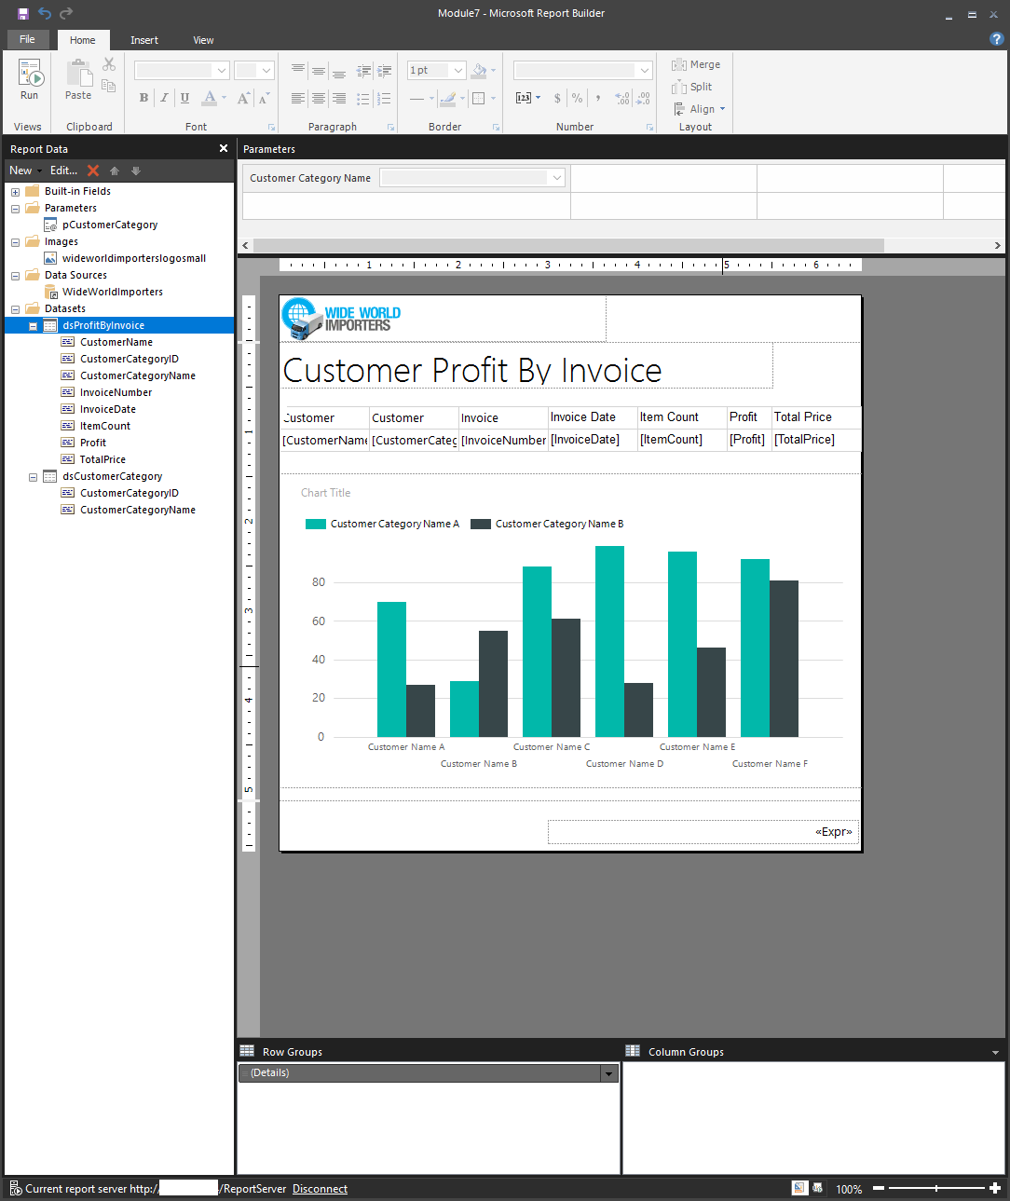
An example of paginated reports can be seen below

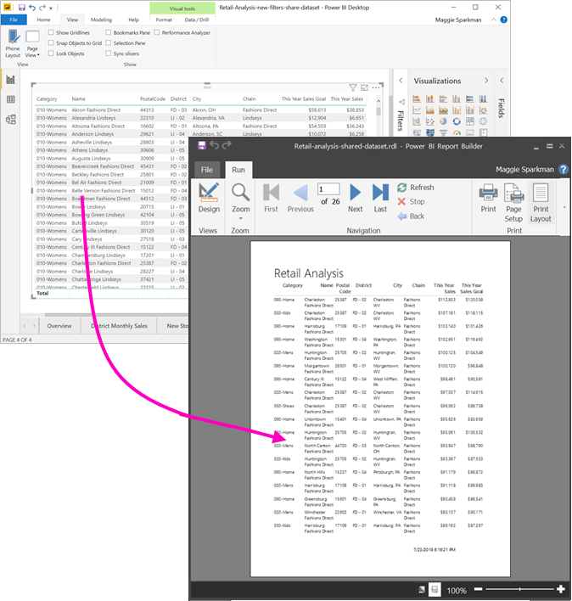

Dashboards – General
A dashboard is a canvas of report elements that can be built in Power BI Service

What is one way that reports and dashboards differ?
- In reports, you can have multiple pages
- In dashboards, you can only have one page

Data Alerts
With dashboards you can set data alerts

Data alerts can be used to notify you or a user that a SPECIFIC DATA POINT is ABOVE, BELOW, or AT A SPECIFIC threshold that you can set

NOTE that alerts are DIFFERENT from subscriptions

They can only be set in the Power BI Service and on SPECIFIC VISUALS such as:
- KPI card
- Gauges
- Cards

After reports have been uploaded to the Power BI service, and you have pinned your chosen visuals to a dashboard. You can then configure alerts like below

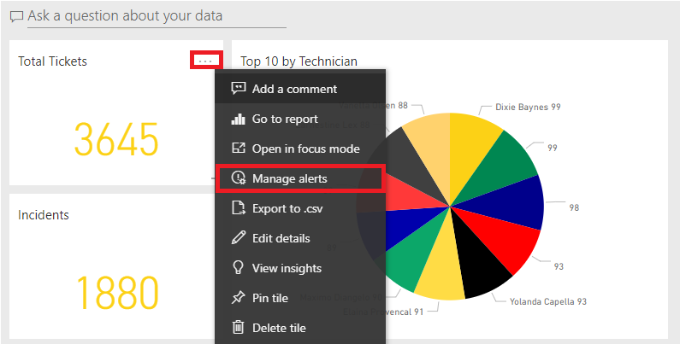

The alerts can then be configured as seen below:

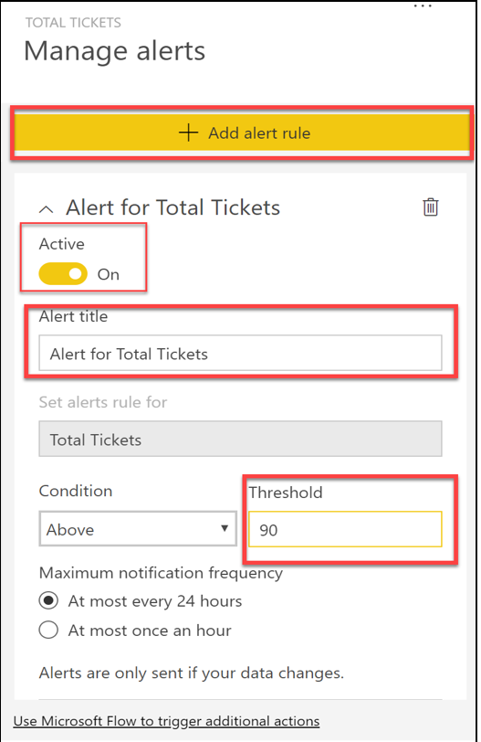

Can also be configured so that the people who receive data alerts are personalized, e.g., only the sales team or those with access to the dashboard
Export Report Data
You can also export report data FROM the Power BI service

You can export data in three formats:
- Excel
- PowerPoint
- PDF

If you enable the Show items with no data option FOR A VISUALIZATION then you WILL NOT be able to export using the underlying data

Set Mobile View
DASHBOARDS can also be configured in mobile view

MOBILE VIEWS for DASHBOARDS can be configured in Power BI Service
MOBILE VIEWS for REPORTS can be configured in Power BI Desktop

To navigate to mobile view in Power BI Desktop, select View on the ribbon
=> and then select Mobile Layout
=> This will redirect you to the mobile view, as shown in the following figure
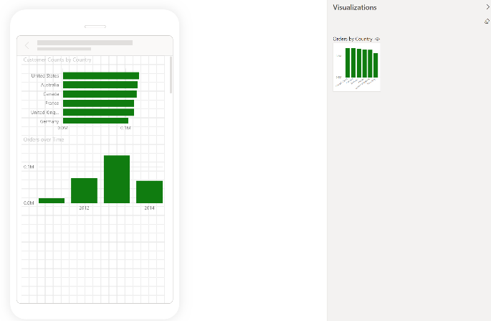

Mobile view emulates the view of a user who is looking at visuals on their phone

You can also optimize dashboards for mobile view

You can do this by selecting the Edit drop down arrow on the Home ribbon

This allows you to edit with Mobile layout and the following view where you can choose which tiles you want to see on the phone view
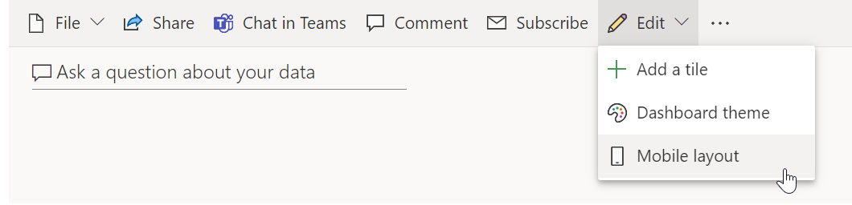
You can also then resize and reorient the tiles and visuals in whichever order you want. The phone view is customizable for each person who uses the dashboard

